**Contact:** Christie Kozak | Leary PR | [christie@learypr.com](mailto:christie@learypr.com) | 978-502-5747

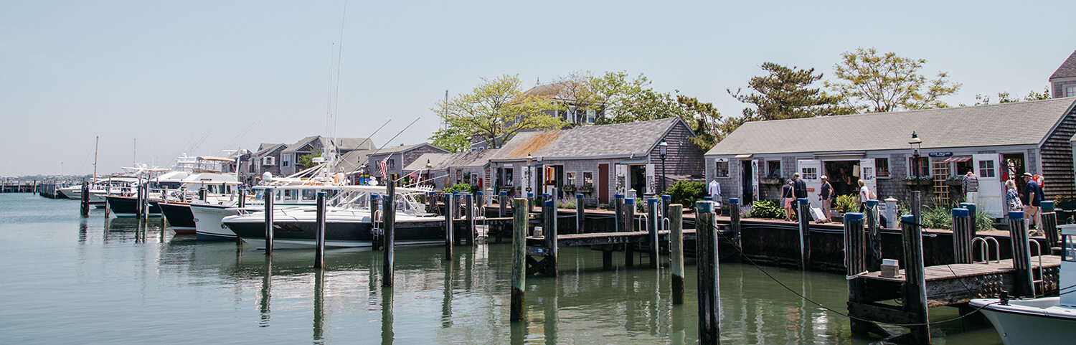

**New Shops and Eateries Open this Season on Nantucket**

NANTUCKET, MASSACHUSETTS (May 2024) – Nantucket welcomes Cou boutique, Nantucket Faraway Chocolate, Snackle, Straight Wharf Fish and The Atelier by isobel & cleo this spring, each bringing new and exciting offerings to the island. All perfectly complement Nantucket’s vibrant shopping and dining scene. For a list of Nantucket shops and restaurants, visit [ShopNantucketIsland.com](http://www.shopnantucketisland.com/).

**Cou Boutique**

5 Old South Wharf • [shopcou.com](http://www.Shopcou.com" \t "_blank)

Cou is a carefully curated women’s wear boutique, with an exclusive offering of both fine jewelry and ready to wear. With a commitment to 'kind luxury’, harmonizing sophistication with ethical practices, emphasizing both style and substance.

**Nantucket Faraway Chocolate**

16 Old South Wharf • [farawaychocolate.com](http://www.farawaychocolate.com)

Experience Faraway Chocolate's handcrafted bean-to-bar artistry by Chef Andre Marrero, celebrating organic, ethically sourced ingredients. A haven for fine chocolate enthusiasts. Made on Nantucket!

**Snackle**

44 Straight Wharf • [acksnackle.com](http://www.acksnackle.com)

A quick serve shop specializing in snacks, salads, wraps, sandwiches, soups, dessert slices & charcuterie/Snackle boards located right next to the Hy-Line Ferry.

**Straight Wharf Fish**

4 Harbor Square • [straightwharffish.com](http://www.straightwharffish.com)

Straight Wharf Fish is a local, sustainable fish market, and a cool, modern clam shack, both under the same roof. Located harborside, in the heart of town, with takeout available.

**The Atelier by isobel & cleo**

5 Courtyard • [isobelandcleo.com](http://www.isobelandcleo.com)

The Atelier by isobel & cleo, features their own knitwear brand as well as small, independent luxury brands from the US and Paris. The Atelier by isobel & cleo offers a selection of womenswear, accessories, and home accents that are ethically and sustainably produced.

**NIR Retail**

NIR Retail, a New England Development company, leases 100 of Nantucket’s premier retail locations found on Nantucket’s most popular shopping streets: Main, Centre, Federal, South Beach and South Water, and on Old South Wharf and Straight Wharf. Shops and galleries include Veronica Beard, Olivela, Southern Tide Nantucket, Skinny Dip Nantucket, Cavalier Ebanks Gallery, Brown Basket Gallery, vineyard vines Nantucket, and Vis-à-vis. Favorite Island restaurants include CRU, Lola 41, Ventuno, The Nantucket Tap Room, The Gaslight Nantucket and more. Located off the coast of Massachusetts, Nantucket has welcomed generations of visitors and residents. Its world-class shops, restaurants, hotels, and seaside beauty have made Nantucket one of the most popular resort destinations for vacationers from around the globe. Visit [ShopNantucketIsland.com](https://www.shopnantucketisland.com/) for a full listing of galleries, shops and restaurants.

**New England Development**

For over 50 years, New England Development has taken a creative, entrepreneurial approach to real estate development and management, delivering, and sustaining successful projects across a wide range of property types. The company’s national portfolio includes mixed-use developments that combine retail, residential, office, lab and hotel use, outlet centers, high-end and street-front retail, airport retail, hotels, golf courses, restaurants, and marinas. New England Development’s diverse portfolio includes CambridgeSide in Cambridge, MA, Chestnut Hill Square in Chestnut Hill, MA, Outlets of Des Moines in Altoona, IA, Clarksburg Premium Outlets in Clarksburg, MD, Newburyport Development and Marinas, Nantucket Island Retail and The White Elephant Resorts, among others. For more information, visit [NEDevelopment.com](http://www.nedevelopment.com/).

# # #