

**Contact:**

Christie Kozak, Leary PR | [christie@learypr.com](mailto:christie@Learypr.com) | 978-502-5747

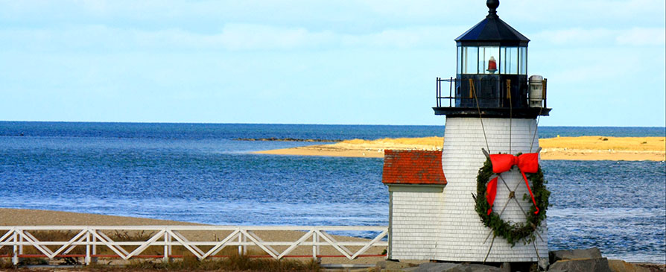

**Retail Stores and Restaurants Participate in**

**Annual Nantucket Christmas Stroll**

***November 30 through December 2, 2018***

NANTUCKET, MASSACHUSETTS (November 2018) – The 45th Annual Christmas Stroll will take place on enchanting Nantucket Island from Friday, November 30 through Sunday, December 2, 2018. Weekend highlights include the arrival of Santa via Coast Guard boat into Nantucket Harbor on Saturday, December 1st. After his arrival, Santa leads the parade through Main Street to the Jared Coffin House where he meets with children young and old. Hundreds of well-adorned Christmas trees line downtown streets. Carolers in Victorian costumes, bell ringers, student choirs and other musicians perform on the Main Street stage as well as stroll through town performing, while visitors enjoy Nantucket's unique shops and restaurants.

This year's theme is “A Beautiful Stroll in the Neighborhood" to commemorate the 50th debut of Mister Rogers’ Neighborhood on PBS. Fred Rogers was a long-time summer resident of the island.

Island visitors can visit the shops on Old South Wharf and enter the Old South Wharf Raffle filled with an array of items you do not want to miss. The winner will be announced on Saturday, December 1st at 4:00 p.m. There is no purchase necessary to enter. Raffle tickets available at Old South Wharf retailers.

Additional highlights of the weekend include:

**Aunt Leah’s Fudge**

**The Courtyard at 16 Straight Wharf**

Featuring Aunt Leah’s special Vanilla Peppermint Stick and Peppermint Bark for the holidays. Open until 6:00 p.m. and featuring complimentary samples all weekend long.

**Beautycounter**

**1 Old South Wharf**

Visit Saturday, December 1st from 3:00 p.m. to 5:00 p.m.to meet Makeup Artist Emily Nantucket (contact [cara.scotto@beautycounter.com](mailto:cara.scotto@beautycounter.com) to make an appointment and walk-ins welcome). Complimentary hot Rum and Cider served all weekend, and Friday through Sunday, receive a FREE Gift with purchase of $150 or more (a travel size Hydrate Body Lotion, full size Lengthening Mascara, and White Coated Canvas Cosmetic bag - while supplies last).

**Bodega**

**2 Candle Street**

Serving complimentary warm cider on Saturday, December 1st for all visitors. Bodega will feature a fish bowl sale all weekend and the store will have a large selection of holiday ornaments and gifts.

**Freedman’s of Nantucket**

**16 Centre Street**

Designer and owner, Don Freedman, will be in attendance all weekend and Freedman’s will be serving their famous homemade ‘glogg’ (an old traditional Christmas Swedish liquor drink) with butter cookies.

All store merchandise will be 50% off and visitors are welcome to enjoy Freedman’s of Nantucket annual award winning holiday display window.

**Isabel Harvey**

**5 Centre Street**

Featuring special events and sales such as buy one get the second at 60% off; exclusive Isabel Harvey cotton Cashmere Nantucket sweaters for sale and extended hours: 9:00 a.m. to 7:00 p.m. Friday, Saturday and Sunday. See store for details.

**Jared Coffin House**

**29 Broad Street**

**Saturday, December 1, 2018**

The Jared Coffin House will once again host Santa Claus in the library upon his arrival to Nantucket. Santa Claus arrives at the Nantucket Boat Basin via a Coast Guard boat, and travels via antique fire truck up Main Street, down Centre Street to the Jared Coffin House. Here he is met by hundreds of children lined up Broad Street, waiting for a chance to meet with him in the Jared Coffin House’s library. The Jared Coffin House will have team members positioned and dressed as holiday elves delivering hot cocoa to the families waiting in line. Visit the ‘Make Your Own Hot Chocolate Bar’ at the Jared Coffin House all Christmas Stroll Weekend.

**Levitate Surf**

**39 Straight Wharf**

Offering complimentary cider for shoppers and 20% off Levitate flannels.

**Love Shack**

**10 Old South Wharf**

Visit the annual sample sale at the Love Shack on Friday and Saturday of Stroll weekend for incredible savings. The sample sale is only held once each year. Love Shack will also sell special hats created for the Stroll.

**Nantucket Boat Basin Authentic Shop**

**33 Straight Wharf**

Visit for authentic Christmas Stroll merchandise, including Nantucket Boat Basin’s popular stroll knit scarf and savings of up to 50% off select merchandise throughout the store.

**Nantucket Peddler**

**37 Straight Wharf**

Offering a variety of Stroll merchandise including new Stroll designs on scarves, hats and long-sleeve tees. Plus, save up to 50% off throughout the store.

**Pete’s Fresh Fish Prints**

**17 Old South Wharf**

Offering complimentary sweet treats and trays of assorted cookies for all shoppers. Specials include $45 priced “9 x 12” framed prints for Stroll weekend.

**Peter England**

**3 & 11 Old South Wharf**

Open Friday, November 30th and Saturday, December 1st from 10:00 a.m. to 4:00 p.m. Special sale section at the 11 Old South Wharf location. Complimentary champagne during open hours.

**REMY**

**16 Old South Wharf**

REMY will feature warm drinks and sweets for shoppers. Specially created handmade ceramic pieces for Stroll will also be available for purchase.

**Skinny Dip**

**23 Old South Wharf**

Open Friday through Sunday with product discounted up to 70% off.

**Southern Tide**

**34 Main Street**

Open all weekend long from 10:00 a.m. to 6:00 p.m. featuring an end-of-season closeout sale. Select spends with will receive a FREE custom Southern Tide Stroll hat. Exciting new Holiday arrivals for Stroll weekend.

**White Elephant’s Brant Point Grill**

**50 Easton Street**

Limited 3 course Dinner Menu starting Thursday, November 29th through Sunday, December 2nd featuring a choice of three appetizers, entrees and desserts for $69 per person. Last Sunday Brunch of the 2018 Season on Sunday December 2nd from 10:00 a.m. to 2:00 p.m. for $59 per person featuring PJ Moody.

Live Music: Sean Lee and the Band on Friday, Saturday and Sunday night from 8:00 p.m.to 10:30 p.m. Last Night of the Season is Sunday, December 2nd with 50% off food sales.

**White Elephant (hotel) Christmas Stroll Package**

Price starting at $2,145 for a standard king room 3 night stay, including breakfast for two daily at the Brant Point Grill. Package features Nantucket Sleigh ride wine, Mistletoe in room and two Nantucket Stroll Scarves. The White Elephant will have an enhanced Port & Cheese offering including a hot chocolate bar with choice of toppings. The Brant Point Grill will be serving Gingerbread Martinis and Pumpkintinis. (Stroll Hotel offer is subject to availability, a three night minimum stay is required. To book call 1-800-475-2637 using booking code STROLL18.)

**Vis-à-Vis**

**34 Main Street**

Shop the holiday sale featuring 20-50% off clothing and shoes. A special gift Bazaar of hats, gloves, jewelry, pillows and Nantucket items will be in-store throughout the weekend.

**NIR Retail**

NIR Retail, a New England Development company, leases 100 of Nantucket’s premier retail locations found on Nantucket’s most popular shopping streets: Main, Centre, Federal, South Beach and South Water, and on Old South Wharf and Straight Wharf. Shops, galleries and restaurants include Southern Tide, Cavalier Gallery, Jack Wills, Style Paris, vineyard vines Nantucket, Vis-a-Vis, CRU, Lola 41, Ventuno and more. Located off the coast of Massachusetts, Nantucket has welcomed generations of visitors and residents. Its world-class shops, restaurants, hotels, and seaside beauty have made Nantucket one of the most popular resort destinations for vacationers from around the globe. Visit [www.ShopNantucketIsland.com](http://www.shopnantucketisland.com/) for a full listing of galleries, shops and restaurants.

**New England Development**

For over forty years, New England Development has taken a creative, entrepreneurial approach to real estate development and management - delivering and sustaining successful projects across a wide range of property types. These projects transform complex challenges into preferred locations, generate long-term value to communities, afford compelling opportunities for local and national businesses, and offer sought-after experiences to a wide range of consumers.

The company is acclaimed for creating some of the country's most widely-recognized and successful regional centers, as well as multifaceted developments that combine retail, residential, hotel, and office uses. Outlet centers, high-end and street-front retail, airport retail, golf courses, restaurants, and marinas round out New England Development's robust portfolio. For more information visit [www.NEDevelopment.com](http://www.nedevelopment.com/).

###