

**Contact:**

Christie Kozak | Leary PR | [christie@learypr.com](mailto:christie@Learypr.com) | 978-502-5747

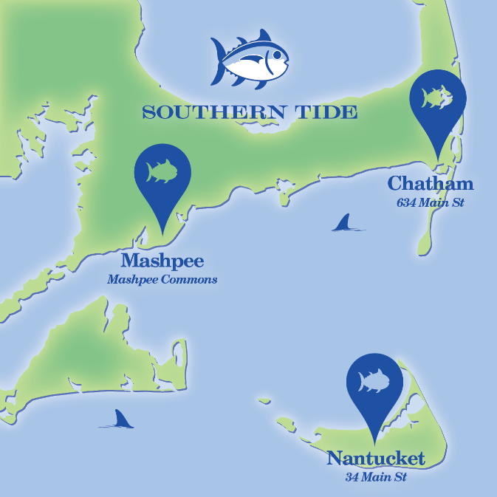

**SOUTHERN TIDE NOW OPEN ON NANTUCKET**

**NEW FASHION BOUTIQUE SPECIALIZING IN MEN’S, WOMEN’S AND BOYS’ APPAREL**

***GRAND OPENING EVENTS SCHEDULED FOR MEMORIAL DAY WEEKEND***

NANTUCKET, MASSACHUSETTS (April 2018) – Southern Tide is a fresh new approach to island fashion, combining the newest trends with cherished classics to offer 'go-to' outfitting for summer on the Cape and Islands. From beach, boat, brewery, or golf course -- to a summer night in town on the cobblestones --Southern Tide offers all the necessary basics for seasonal living for men, women, and boys. Southern Tide is classic, coastal, and adventurous; a new and exciting lifestyle brand.

Southern Tide is located at 34 Main Street in Nantucket with additional stores in Chatham & Mashpee. Open now, look for a lineup of Grand Opening Weekend Events scheduled for Memorial Day Weekend 2018 on Island.  For more information, visit [www.SouthernTideNantucket.com](http://www.southerntidenantucket.com/).

**NIR Retail**

NIR Retail, a New England Development company, leases 100 of Nantucket’s premier retail locations found on Nantucket’s most popular shopping streets: Main, Centre, Federal, South Beach and South Water, and on Old South Wharf and Straight Wharf. Shops, galleries and restaurants include Southern Tide, Cavalier Galleries, Jack Wills, Style Paris, vineyard vines Nantucket, Vis-a-Vis, CRU, LoLa 41, Ventuno and more. Located off the coast of Massachusetts, Nantucket has welcomed generations of visitors and residents. Its world-class shops, restaurants, hotels, and seaside beauty have made Nantucket one of the most popular resort destinations for vacationers from around the globe. Visit [www.ShopNantucketIsland.com](http://www.ShopNantucketIsland.com) for a full listing of galleries, shops and restaurants.

**New England Development**

For over forty years, New England Development has taken a creative, entrepreneurial approach to real estate development and management - delivering and sustaining successful projects across a wide range of property types. These projects transform complex challenges into preferred locations, generate long-term value to communities, afford compelling opportunities for local and national businesses, and offer sought-after experiences to a wide range of consumers.

The company is acclaimed for creating some of the country's most widely-recognized and successful regional centers, as well as multifaceted developments that combine retail, residential, hotel, and office uses. Outlet centers, high-end and street-front retail, airport retail, golf courses, restaurants, and marinas round out New England Development's robust portfolio. For more information visit [www.NEDevelopment.com](http://www.nedevelopment.com/).

###