

**Contact:**

Christie Kozak | Leary PR | [christie@learypr.com](mailto:christie@Learypr.com) | 978-502-5747

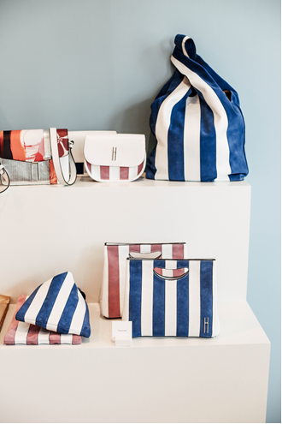



**Fashion and Philanthropy Boutique Olivela Announces**

**Summer Pop-Up Trunk Shows and Special Events on Nantucket**

***Luxury fashion platform creates unique & socially meaningful Pop-up destination this summer***

NANTUCKET, MASSACHUSETTS (Summer 2018) *–* Olivela ([olivela.com](https://www.olivela.com/)), a unique fashion and socially impactful shopping experience, is now open on Nantucket at 25 Centre Street in the heart of the island’s most visited upscale shopping destination. Olivela features an expertly curated assortment of top designer brands, including Dior, Stella McCartney, Hayward, Giuseppe Zanotti and Aquazzura, where 20% of every purchase goes towards educating girls around the world. (*Pictured: Hayward Bags*)

Olivela will host a number of special events this season, showcasing top designers. For up-to-the-minute event scheduling and times visit <https://www.olivela.com/shop/nantucket-store>. Summer 2018 Pop-Up Trunk Shows and Special Events at Olivela include:

7/12-7/13

**Sunday Riley Facial Party**

Sunday Riley is offering 30-minute facials at the Olivela boutique from 11am to 6pm. Sign up for a complimentary facial in-store or online. Spaces are limited.

7/14-7/15

**Gurhan Jewelry Trunk Show**

7/19-7/22

**John Hardy Jewelry Trunk Show with Bracelet Bar**

7/26

**Hayward Bag Trunk Show & Book Signing with Marin Hopper**

Marin Hopper will be signing the re-release of DENNIS HOPPER: 1961-1967 featuring photographs taken by her late father, actor, filmmaker, photographer and artist Dennis Hopper. Hopper will also be presenting a coveted collection of Hayward handbags, an American luxury fashion brand that draws on generations of Hollywood history and glamour. Enjoy a glass of champagne, browse the collection and meet Marin. The book signing will take place from 4:00 p.m. to 6:00 p.m.

7/28

**The Beauty Chef: Beauty Inside and Out - Tasting Event**

7/28

**Joanna Vargas: Beauty Inside and Out - Mask Bar Event**

8/1-8/3

**Pippa Small: Jewelry Trunk Show & Personal Appearance by Pippa Small**

8/4-8/6

**Roberto Coin Jewelry Trunk Show**

8/7-8/9

**Larkspur & Hawk Jewelry Trunk Show**

8/10-8/14

**Marla Aaron Jewelry Trunk Show**

8/15-8/17

**Temple St. Clair Jewelry Trunk Show**

8/18-8/20

**Zoe Chicco: Jewelry Trunk Show & Personal Appearance by Zoe Chicco**

8/21-8/23

**Emily Wheeler Jewelry Trunk Show**

**About Olivela**

Olivela is a luxury fashion platform that offers unique styles from the world's best designers with 20% of each sale directly benefiting the education of girls worldwide through best-in-class partners CARE, Malala Fund, and Too Young to Wed.

**NIR Retail**

NIR Retail, a New England Development company, leases 100 of Nantucket’s premier retail locations found on Nantucket’s most popular shopping streets: Main, Centre, Federal, South Beach and South Water, and on Old South Wharf and Straight Wharf. Shops, galleries and restaurants include Southern Tide, Cavalier Gallery, Jack Wills, Style Paris, vineyard vines Nantucket, Vis-a-Vis, CRU, Lola 41, Ventuno, and more. Located off the coast of Massachusetts, Nantucket has welcomed generations of visitors and residents. Its world-class shops, restaurants, hotels, and seaside beauty have made Nantucket one of the most popular resort destinations for vacationers from around the globe. Visit [www.ShopNantucketIsland.com](http://www.shopnantucketisland.com/) for a full listing of galleries, shops and restaurants.

**New England Development**

For over forty years, New England Development has taken a creative, entrepreneurial approach to real estate development and management - delivering and sustaining successful projects across a wide range of property types. These projects transform complex challenges into preferred locations, generate long-term value to communities, afford compelling opportunities for local and national businesses, and offer sought-after experiences to a wide range of consumers.

The company is acclaimed for creating some of the country's most widely-recognized and successful regional centers, as well as multifaceted developments that combine retail, residential, hotel, and office uses. Outlet centers, high-end and street-front retail, airport retail, golf courses, restaurants, and marinas round out New England Development's robust portfolio. For more information visit [www.NEDevelopment.com](http://www.nedevelopment.com/).

###