Contact:
Christie Kozak | Leary PR | christie@learypr.com | 978-502-5747

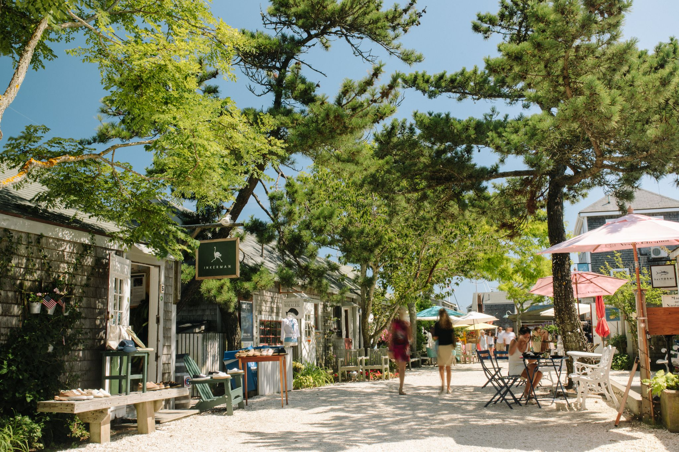

New Nantucket Boutiques and Restaurant to Open for the 2020 Season

NANTUCKET, MASSACHUSETTS (June 2020) – Summer 2020 will see the addition of new boutiques on Nantucket and the late summer reopening of the beloved Nantucket Tap Room at the Jared Coffin House, following a total refurbishment.

The new retailers and refurbished eatery join a robust roster of over 100 premier shopping boutiques and restaurants. For a listing of the Island’s many places to shop and dine visit, ShopNantucketIsland.com.

Anna P. Jay
14 Federal Street, annapjay.com
Anna P. Jay was founded on the ideals of giving clients distinctive, artistic, and unparalleled pieces of fine jewelry. She offers an experience that is as special as the gems she procures with transparency, ease, and unmatched customer service.

Centre Pointe
22 Centre Street, 28centrepointe.com
A lifestyle store with a fresh twist on classic Nantucket coastal chic, with a curated collection of home decor, jewelry, and gifts. Featuring exclusive products by ASHA, OOMPH, Aerin Lauder and Amanda Lindroth, as well as original artwork by Caroline Chriss and local artist Meredith Hanson. The perfect place to find a piece of Nantucket to bring home. New this season, introducing a private label, consisting of Cashmere sweaters and dresses.

Grace Geier
The Courtyard at 16 Straight Wharf, gracegeierack.com
Grace Geier is a new boutique opening for the first season on Straight Wharf. Find a beautifully curated collection of the owner’s favorite styles including breezy beachwear, simple dresses to take you from day to night, American made denim and classic cocktail dresses. Grace Geier provides the islanders and tourists with a simple but elegant collection embodying a coastal timeless style.

Respoke
41 Straight Wharf, respoke.com
Cape Cod native Michael Tonello, best-selling author of Bringing Home the Birkin, is delighted to share with Nantucket a new take on his favorite summer accessory. Respoke espadrilles, ready-to-wear, and accessories, are made from authenticated iconic designer silk scarves (Gucci, Pucci, Hermès, among others). Every item is eco-friendly; every pair is unique. In the tradition of finely crafted products, Respoke espadrilles are hand-made and hand-stitched by multi-generational craftspeople in La Rioja, Spain.

The Nantucket Tap Room at the Jared Coffin House
29 Broad Street, jaredcoffinhouse.com
The Nantucket Tap Room will reopen late summer after a total refurbishment in its original quarters at the Jared Coffin House. The complete remodel of The Nantucket Tap Room will connect the pub and eatery with the main hotel lobby and patio. The Nantucket Tap Room is a renewal of a classic meeting place, celebrating the history, traditions, and people of Nantucket, offering approachable food and beverage options in the historic Jared Coffin House.

Veronica Beard
11 South Water Street, veronicabeard.com
Thoughtfully designed with feminine silhouettes and refined tailoring, the Veronica Beard collection is intuitively built for real life - empowering her from day to night, work to weekend, and everywhere in between. Veronica Beard believes in building a collection that is inclusive of women everywhere, and makes them feel confident every single day. The collection’s creators are mothers, entrepreneurs, sisters, friends - and are the Veronica Beard customer themselves. Their motto: Look good, feel good, and do what you love.

NIR Retail
NIR Retail, a New England Development company, leases 100 of Nantucket’s premier retail locations found on Nantucket’s most popular shopping streets: Main, Centre, Federal, South Beach and South Water, and on Old South Wharf and Straight Wharf. Shops, galleries and restaurants include Veronica Beard, Olivela, Southern Tide Nantucket, Cavalier Ebanks Gallery, Style Paris, vineyard vines Nantucket, Vis-a-Vis, CRU, Lola 41, Ventuno, The Nantucket Tap Room and more. Located off the coast of Massachusetts, Nantucket has welcomed generations of visitors and residents. Its world-class shops, restaurants, hotels, and seaside beauty have made Nantucket one of the most popular resort destinations for vacationers from around the globe. Visit ShopNantucketIsland.com for a full listing of galleries, shops and restaurants.

New England Development
For over forty years, New England Development has taken a creative, entrepreneurial approach to real estate development and management - delivering and sustaining successful projects across a wide range of property types. These projects transform complex challenges into preferred locations, generate long-term value to communities, afford compelling opportunities for local and national businesses, and offer sought-after experiences to a wide range of consumers. The company is acclaimed for creating some of the country's most widely recognized and successful regional centers, as well as multifaceted developments that combine retail, residential, hotel, and office uses. Outlet centers, high-end and street-front retail, airport retail, golf courses, restaurants, and marinas round out New England Development's robust portfolio. For more information, visit NEDevelopment.com.

# # #

