**Contact:** Christie Kozak | Leary PR | [christie@learypr.com](mailto:christie@learypr.com) | 978-502-5747

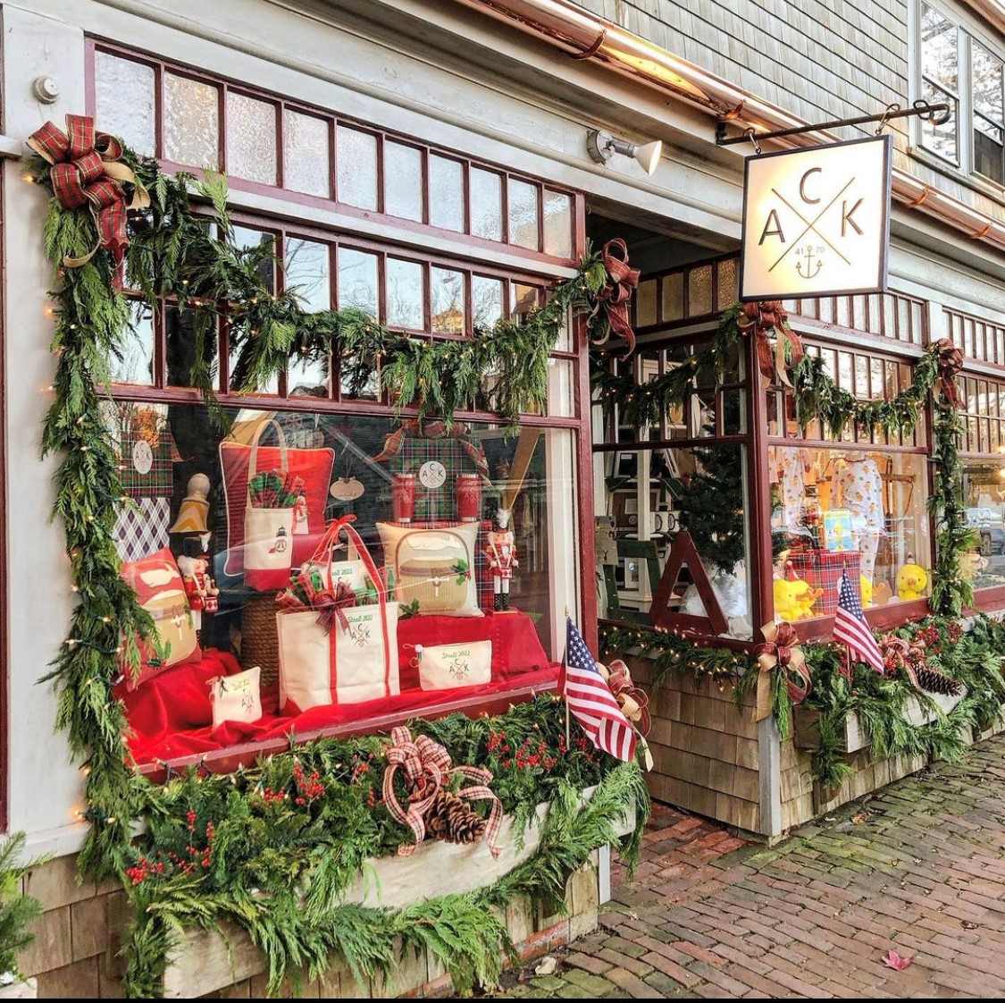

**48th Annual Nantucket Holiday Stroll Weekend**

***Friday, December 2 through Sunday, December 4, 2022***

NANTUCKET, MASSACHUSETTS (Holiday 2022) – Celebrate the 48th annual Nantucket Stroll Weekend from Friday, December 2 through Sunday, December 4, 2022. Santa arrives Saturday on a Coast Guard vessel and rides down Main Street on his bright red fire truck with the Town Crier, carolers, choirs, and other musicians. Nantucket's unique shops and restaurants will celebrate Stroll Weekend with special sales, promotions, and holiday cheer. For a listing of shops, restaurants, and accommodations, visit [ShopNantucketIsland.com](https://www.shopnantucketisland.com/).

Stroll Weekend specials include:

**ACK 4170**

18B Federal Street

ACK 4170 boutique features high-quality, Nantucket-inspired candles, pillows, holiday ornaments, apparel, jewelry, home décor, and more, with special savings on Stroll totes and other items.

**Bodega**

2 Candle Street

Stroll Cashmere Sale: cashmere throws originally $148 on sale for $99.  Many colors to choose from.

**Cattivo**

20 Centre Street

Open Stroll weekend from 10:00 a.m. to 6:00 p.m. offering free spirits and sweets to shoppers. Specials include $20 merchandise bins and 40% off all full priced clothing.

**Freedman’s of Nantucket**

14 Centre Street

Save up to 40% off the entire store.

**G.S. Hill Gallery**

40 Straight Wharf

Visit G.S. Hill Gallery on Saturday of Stroll Weekend for their annual free raffle drawing. Tickets are free to shoppers. Must be present to win.

**Love Shack**

10 Old South Wharf

For the first time ever, all of the full price LOLA jewelry in stock at the store will be on sale for 20% off. A limited quantity of stroll hats will also be available.

**Nantucket Boat Basin Authentic Shop**

33 Straight Wharf

Visit the Nantucket Boat Basin on Straight Wharf for authentic stroll merchandise including hats, scarves and more – including the official 2022 Nantucket Christmas Stroll knit scarf. Plus, save up to 50% off select merchandise.

**Oath Pizza**

44 Straight Wharf

Open all weekend from 11:30 a.m. to 9:00 p.m. daily (8:00 p.m. on Sunday). Patrons will receive a free Oath branded “Pizza is my Therapy” tote bag with every order (while supplies last).   
  
**Olivela**

25 Centre Street

Featuring top brands, fine jewelry and holiday beauty gift sets.

**REMY**

2 Old South Wharf

Enjoy snacks and sips and a giveaway with purchases over $150.

**Skinny Dip Nantucket**

23 Old South Wharf

Offering 40% off for most items in store.

**Vanderbilt Gallery**

18C Federal Street

Save up to 50% select clothing and jewelry.

**The Club Car**

1 Main Street

Enjoy live piano music on Thursday, Friday and Saturday and take in the amazing holiday décor inside the bar and dining room.

**The Nantucket Tap Room**

**Jared Coffin House**

The annual Patio Dance Party is on for Saturday afternoon of Stroll weekend (weather permitting).

**NIR Retail**

NIR Retail, a New England Development company, leases 100 of Nantucket’s premier retail locations found on Nantucket’s most popular shopping streets: Main, Centre, Federal, South Beach and South Water, and on Old South Wharf and Straight Wharf. Shops and galleries include Veronica Beard, Olivela, Southern Tide Nantucket, Skinny Dip Nantucket, Cavalier Ebanks Gallery, Brown Basket Gallery, Style Paris, vineyard vines Nantucket, and Vis-à-vis. Favorite Island restaurants include CRU, Lola 41, Ventuno, The Nantucket Tap Room, The Gaslight Nantucket and more. Located off the coast of Massachusetts, Nantucket has welcomed generations of visitors and residents. Its world-class shops, restaurants, hotels, and seaside beauty have made Nantucket one of the most popular resort destinations for vacationers from around the globe. Visit [ShopNantucketIsland.com](https://www.shopnantucketisland.com/) for a full listing of galleries, shops and restaurants.

**New England Development**

For over forty years, New England Development has taken a creative, entrepreneurial approach to real estate development and management - delivering and sustaining successful projects across a wide range of property types. These projects transform complex challenges into preferred locations, generate long-term value to communities, afford compelling opportunities for local and national businesses, and offer sought-after experiences to a wide range of consumers.

The company is acclaimed for creating some of the country's most widely-recognized and successful regional centers, as well as multifaceted developments that combine retail, residential, hotel, and office uses. Outlet centers, high-end and street-front retail, airport retail, golf courses, restaurants, and marinas round out New England Development's robust portfolio. For more information, visit [NEDevelopment.com](https://nedevelopment.com/).

# # #