Contact:
Christie Kozak | Leary PR | christie@learypr.com | 978-502-5747

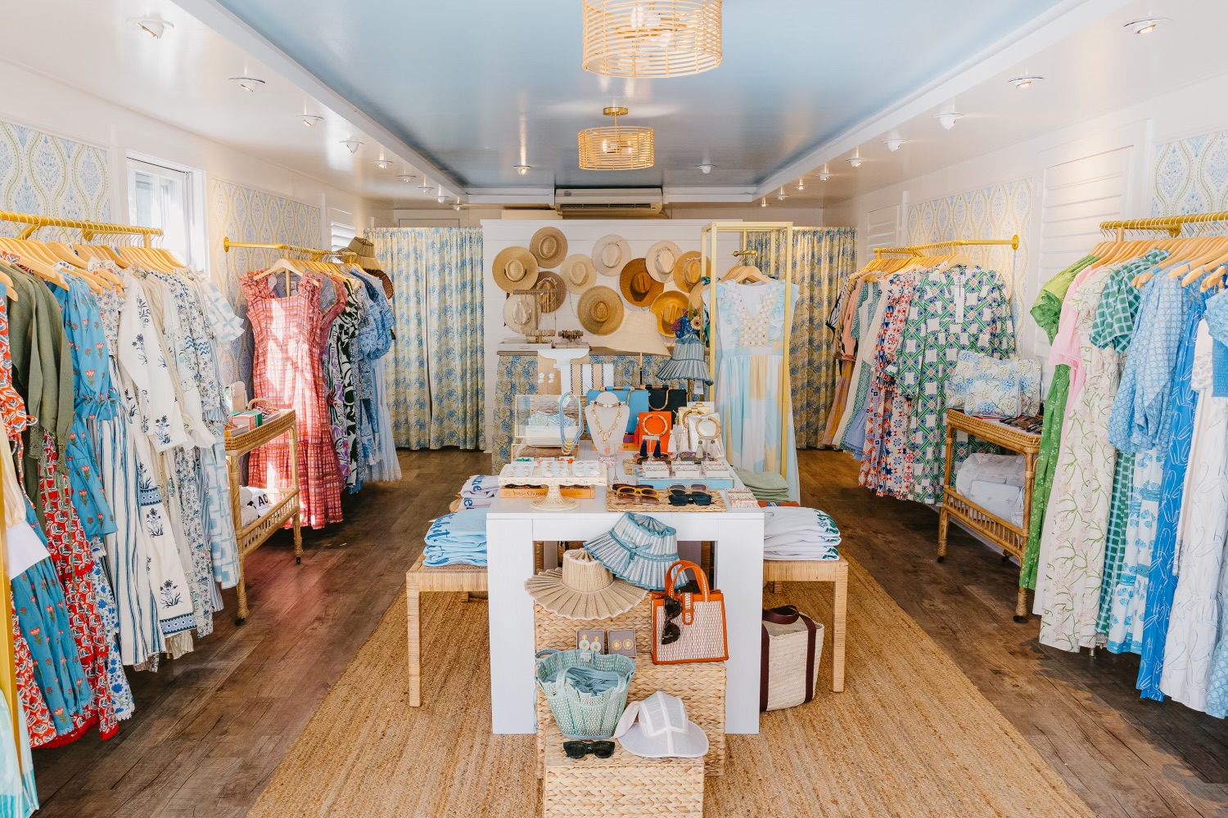

Beau & Ro Now Open on Nantucket

NANTUCKET, MASSACHUSETTS (May 2023) – Charleston’s favorite boutique, Beau & Ro, is now open at 4 Federal Street in downtown Nantucket. A jewel box destination for upbeat and effortless dressing, Beau & Ro features apparel, bags, accessories, and gifts. The boutique will showcase Beau & Ro’s apparel, an exclusive collection of unique designs created in the retailer’s own fair-trade factory, Olive Workshop. Olive Workshop, founded by owners, Sara Rossi and her fiancé, a Delhi native, was launched to increase transparency in the production process and offers a supportive and inspiring environment for stitchers in India.
Alongside Beau & Ro’s collection, Sara has curated a mix of her favorite brands from around the world including Coco Shop, Daydress, Eddy, Ephemera, Odile, Sue Sartor, HART, Lorna Murray, Lack of Color, Le Specs, and many more. Sara designed the shop to be colorful and calming with playful prints and patterns, just like the merchandise.

Sara Rossi elaborates on the opening, “My family started vacationing on Nantucket over 30 years ago and after launching Beau & Ro, the island contributed to much of the early success of the brand. From my first trunk show ever at Eye of the Needle, to CRU waitresses wearing our signature belt bags, to opening the Skinny Dip in 2016, I’ve seen the island evolve, but one constant is the supportiveness of this community. Our Charleston store has been so well received on King Street and I am excited to bring a little bit of that Beau & Ro magic to this special island!”
NIR Retail
NIR Retail, a New England Development company, leases 100 of Nantucket’s premier retail locations found on Nantucket’s most popular shopping streets: Main, Centre, Federal, South Beach and South Water, and on Old South Wharf and Straight Wharf. Shops and galleries include Veronica Beard, Olivela, Southern Tide Nantucket, Skinny Dip Nantucket, Cavalier Ebanks Gallery, Brown Basket Gallery, Style Paris, vineyard vines Nantucket, and Vis-à-vis. Favorite Island restaurants include CRU, Lola 41, Ventuno, The Nantucket Tap Room, The Gaslight Nantucket and more. Located off the coast of Massachusetts, Nantucket has welcomed generations of visitors and residents. Its world-class shops, restaurants, hotels, and seaside beauty have made Nantucket one of the most popular resort destinations for vacationers from around the globe. Visit ShopNantucketIsland.com for a full listing of galleries, shops and restaurants.

New England Development
For over forty years, New England Development has taken a creative, entrepreneurial approach to real estate development and management - delivering and sustaining successful projects across a wide range of property types. These projects transform complex challenges into preferred locations, generate long-term value to communities, afford compelling opportunities for local and national businesses, and offer sought-after experiences to a wide range of consumers. The company is acclaimed for creating some of the country's most widely-recognized and successful regional centers, as well as multifaceted developments that combine retail, residential, hotel, and office uses. Outlet centers, high-end and street-front retail, airport retail, golf courses, restaurants, and marinas round out New England Development's robust portfolio. For more information, visit NEDevelopment.com.

# # #

